Examining Tree Phenology: Using Drone Based Aerial Images to Quantify Phenological Events

Bailey M. Costello

Floyd, Virginia

A Thesis presented to the Faculty

of the University of Virginia

in Fulfillment of the

Distinguished Majors Program

Department of Environmental Sciences

University of Virginia

April 2019

Xi Yang,

Thesis Advisor

Thomas A. Smith,

Director of Distinguished Major Program

**ABSTRACT**

The study of phenology has historic context, but it is especially important today as a result of climate change. Leaf-out and senescence events are shifting temporally, which has ramifications for the water cycle, carbon cycle, plant-animal interactions, and industry. Observing tree phenology can help us build models in order to predict future phenology changes resulting from warmer temperatures. There are several methods used to monitor tree phenology such as field observations, satellite data, and phenocams. However, these methods have spatial, temporal, and resolution based limitations. In this study, images of a forest section in Virginia were taken using a digital camera attached to a lightweight drone. After finding the relative greenness (GCC) for individual trees, start of season dates were calculated for each tree with sufficient data. A spatial variability map was created which suggested the presence of microclimates within the study area. The relationship between start of season and maximum tree height was examined, in addition to the relationship between start of season and maximum greenness. Tree height was also plotted against tree crown area and we found no correlation between any of these variables. We posit that these correlations are strongly species dependent and the lack of species information in this study was responsible for the weak relationships. This study also examined the practicality, efficiency, and accuracy of using drones to collect data on a large number of trees. We found that drone sensed data, while useful due to high spatial resolution and flexible temporal resolution, is subject to interference from meteorological conditions, primarily wind.

**ACKNOWLEDGMENTS**

I thank my advisor, Professor Xi Yang, for his time, guidance, and encouragement on this project. I also thank Atticus Stovall for his help with data collection and insights on GIS. I am grateful for the assistance of Nina Copeland, Amy Doan, and Ben Masters with data processing.

**TABLE OF CONTENTS**

Abstract ………………………………………………………………………… i

Acknowledgements …………………………………………………………….. ii

Table of Contents ………………………………………………………………. iii

List of Figures ………………………………………………………………….. iv

List of Tables …………………………………………………………………… v

Introduction …………………………………………………………………….. 1

Methods ………………………………………………………………………… 4

Data Collection ………………………………………………………….. 4

Processing ……………………………………………………………….. 6

Analysis …………………………………………………………………. 8

Results ………………………………………………………………………….. 11

Discussion ……………………………………………………………………… 16

Drone Methodology …………………………………………………….. 16

Relationships ……………………………………………………………. 17

Future Work …………………………………………………………….. 18

References ……………………………………………………………………… 20

**LIST OF FIGURES**

|  |  |  |
| --- | --- | --- |
| Figure 1 | Study area located near Palmyra, Virginia in relation to Charlottesville, Virginia (left) and DJI Mavic Pro with a RGB digital camera (right) | 5 |
|  |
| Figure 2 | Study site near Palmyra, Virginia with 500x200 m dimensions and delineated tree crowns | 5 |
| Figure 3 | Two examples of how the polygons were manually shifted to increase accuracy, with the blue polygon as before correction and the red polygon as after correction. 3A shows a shift of 4.7 m and 3B shows a shift of 1.6 m | 7 |
| Figure 4 | Examples of the orthomosaics with dates ranging from day of year 120 (4/24/2018) to day of year 315 (11/11/2018) | 7 |
| Figure 5 | Phenology curve for tree 241 where the green bar represents the budburst and the orange bar represents fall senescence | 9 |
| Figure 6 | Examples of Gcc data over time with a fitted curve (eqn. 2) | 10 |
| Figure 7 | Histogram showing the number of trees for the start of season dates | 11 |
| Figure 8 | Histogram showing number of trees for the end of season dates | 11 |
| Figure 9 | A spatial variability map where lighter shades of blue correspond to earlier start of season and darker shades of blue correspond to later start of season. The 5 buffer areas are labeled A-E. | 12 |
| Figure 10 | Histograms showing start of season labeled A-E that correspond to the buffers in Figure 9. | 13 |
| Figure 11 | Maximum tree height in meters and start of season in day of year. | 14 |
| Figure 12 | Start of season in day of year and maximum GCC. | 14 |
| Figure 13 | Maximum tree height in meters and tree crown area in square meters. | 15 |

**LIST OF TABLES**

|  |  |  |
| --- | --- | --- |
| Table 1 | Parameters used in equation 1 to create phenology curve. | 11 |

**Introduction**

Understanding the phenology of a forest ecosystem is helpful when examining carbon and water cycles, especially in the context of climate change. Leaf-out, defined as the emergence of leaves on deciduous trees and regarded as the beginning of the growing season, usually occurs earlier during warm years and later during cool years. Here, start of season is defined as the period during the year when a particular species experiences the fastest growth rate. Consequentially, start of season times in temperate forests can be good indicators of climate change (Polgar and Primack 2011; Way 2011; Yang et al., 2014). While leaf-out marks often marks the beginning of the growing season, senescence is correlated with the color change in leaves and signals the end of the growing season. Additionally, changes in leaf-out (start of season) and senescence (end of season) dates can have implications for the carbon cycle. An earlier start to the growing season results in more carbon sequestration in the spring; however, warmer autumns can result in a net release of carbon due to a higher rate of respiration (Keenan et al., 2014).

Besides gaining a better understanding of the abiotic cycles and effects of climate change, the ability to observe and model forest phenology has other uses. The fruit tree industry and maple sugar industry are dependent on leaf-out timing. A warmer climate that results in earlier leaf-out can increases photosynthesis, resulting in increased biomass and greater economic value. However, it can put trees in greater danger of damage from a late frost and therefore hurt the industry (Polgar and Primack, 2011). Forest phenology is also important in plant-animal interactions. The change in plant phenology can cause phenological asynchrony between animals and the plants they require for food or habitat. In the case of several butterfly species, an asynchrony resulted in population reduction and even extinction. Many animal species are able to adapt to changing plant phenology by altering their ranges, but this can have further ecological effects (Parmesan, 2006).

Observed phenology patterns can have implications for structure and function of trees. Changes in greenness during the spring are driven by leaf color as was well as canopy structure. During the summer, there is a slight decrease in greenness, which is related to leaf ontogeny, structure, and pigmentation. In a study by Keenan et al. (2014), the authors found that the greenness value reaches its maximum before the leaves are even half their final size. This finding reinforces the idea that canopy greenness is a related to both leaf color and leaf structure (Keenan et al., 2014). In another study examining a single species of deciduous tree, the author found that start of season for individual trees was related to tree height. The date determined for start of season was later for taller trees, and taller trees also had a shorter leaf emergence duration (Seiwa, 1998).

Climate change has an effect on leaf-out and senescence timing. Increasing temperatures in mid to high latitudes has caused leaf-out to occur earlier and senescence to occur later, expanding the growing season by nearly 11 days since the 1960s. However, some tree species use day length instead of temperature as a major control in their phenology, so a warming climate does not necessarily correlate with a longer growing season for all trees (Way, 2011). Monitoring phenology is necessary in order to create models that can predict future phenology as the climate continues to change.

There have been many methods used to monitor forest phenology, each with their limitations. Satellite data is popular because of the constant monitoring and global extent; however, there are several issues with this method. The spatial resolution (1 km to 10 m) is often not adequate when observing phenology on the local or species scale. Satellite data that offers 10 m resolution is often expensive and closely spaced repeat times often require an oblique view that can distort the data (Anderson, 2013). Additionally, satellite data can be disrupted due to atmospheric conditions such as clouds, fog, and aerosols (Parihar et al., 2013). Another option in monitoring phenology is phenocams which provide inexpensive, continuous, high resolution data. However, the data from this method is limited spatially by the camera’s field of view (Xu et al. 2014; Klosterman et al., 2018). The recent improvements in UAV technology have made drones more accessible and inexpensive. Using the same camera technology as a stationary phenocam, a drone can be equipped with a digital camera that allows for the collection of high resolution data over a larger area. The increase in spatial resolution allows for phenology events to be more reliably measured (Klosterman et al., 2018).

Previous studies have successfully demonstrated the effectiveness of using drones to observe forest phenology. In a study by Berra et al, researchers used a drone to discriminate between five deciduous tree species for a total of 577 trees (2016). Another study used a drone to examine the phenology of individual trees from budburst to leaf fall. Additionally, this study examined the effect that a microclimate created by a nearby stream had on phenology (Klosterman and Richardson, 2018). A study by Zhang et al provided evidence that drones are useful in long-term ecological monitoring and offer a more cost effective option than traditional methods (2016).

In this project, a drone equipped with a digital camera was used to observe tree phenology in a temperate forest in Virginia. The first goal of this research project was to determine the extent to which drone-based aerial images can be used to observe tree phenology. A large number of trees were observed in order to increase the accuracy of temporal and spatial patterns. The second goal was to assess potential correlations between multiple variables such as tree height, crown area, spatial distribution, maximum greenness, and phenological events.

**Methods**

*Data Collection*

Pictures were taken at 2.5 centimeter resolution with a digital camera attached to a DJI Mavic Pro drone. The drone flew at a height of 90 m and took between 700-1300 pictures, depending on meteorological conditions at the time of the flight. Fog, wind, or other adverse weather can shorten the flight time because the drone either cannot fly or the data collected would be too inaccurate. Only one date was unusable due to fog, but there were several scheduled flights that had to be cancelled due to weather conditions. The mobile application DJI GO 4 was used for camera calibration and the application DroneDeploy was used to create the flight plan and begin the flight. The camera was calibrated with a custom white balance of 6000 K, a front overlap of 75%, and a side overlap of 65%. The study site, shown in figure 2, is an approximately 500x200 m section of temperate forest in Palmyra, Virginia. The study site includes both evergreen and deciduous trees of mixed age and species. Images were collected between March 2018 and November 2018, for a total of 28 dates. The drone was flown approximately every week during the spring, every two weeks during the summer, and weekly during the fall. In order for phenological processes to be captured, images were collected with a temporal resolution of roughly one week (Yang et al. 2014). Height information was gathered for each tree crown from aerial LIDAR data that was previously collected for a separate study.

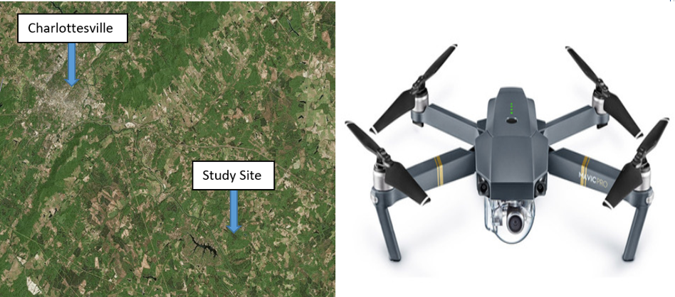Figure 1: Study area located near Palmyra, Virginia in relation to Charlottesville, Virginia (left) and DJI Mavic Pro with a RGB digital camera (right).

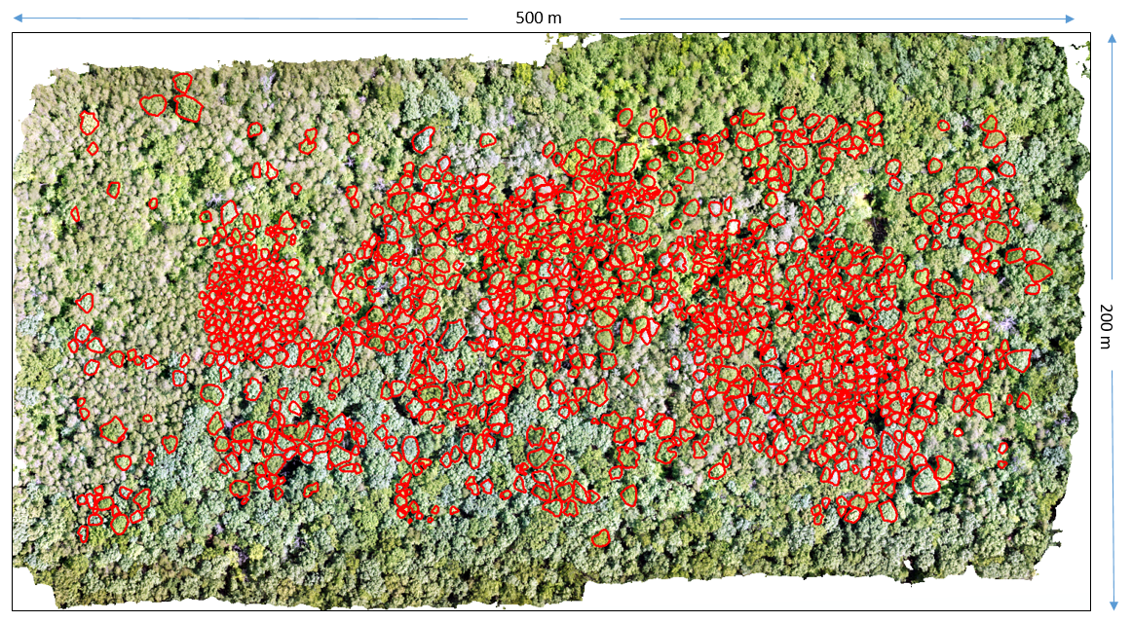

Figure 2: Study site near Palmyra, Virginia with 500x200 m dimensions and delineated tree crowns.

*Processing*

The images taken by the Mavic Pro were uploaded to Agisoft Photoscan to create an orthomosaic (Figure 4). To create the orthomosaic, a batch process was used with the following parameters: key points=0, tie points=0, accuracy=high, generic preselection=off, dense cloud=high quality. The selection of 0 for key points and tie points corresponded to infinite points for each, which was especially important during dates with limited leaf cover because Agisoft Photoscan had difficulty finding points in common among the raw images. The orthomosaics were then imported to ArcMap at a 3 cm resolution. The tree crowns in a single orthomosaic were delineated using the polygon construction tool and a single shapefile was created that included 1203 crowns. This shapefile was then used for every successive orthomosaic as a way to keep the area of each crown constant through time. Due to varying wind speeds during flights, the tree crowns in the orthomosaics did not initially line up with the polygon shapefile. In some instances, as shown in Figure 3A, the actual tree crowns were up to 4.7 m away from the correct tree crown polygon. To correct for this, the polygons were shifted, either individually or in groups, so that the polygons lined up with the tree crowns with an accuracy of around 3 cm.

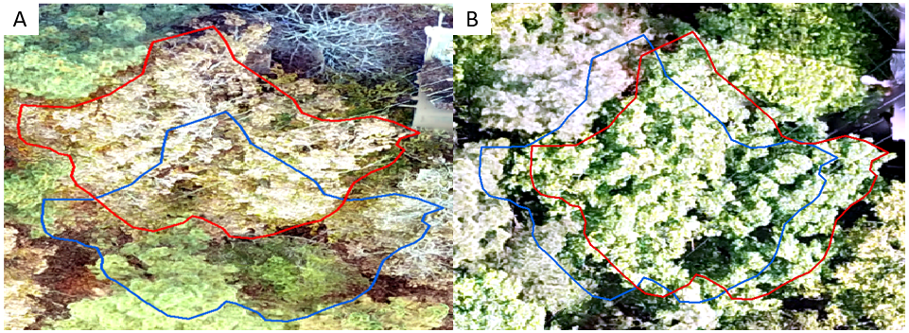

Figure 3: Two examples of how the polygons were manually shifted to increase accuracy, with the blue polygon as before correction and the red polygon as after correction. 3A shows a shift of 4.7 m and 3B shows a shift of 1.6 m.

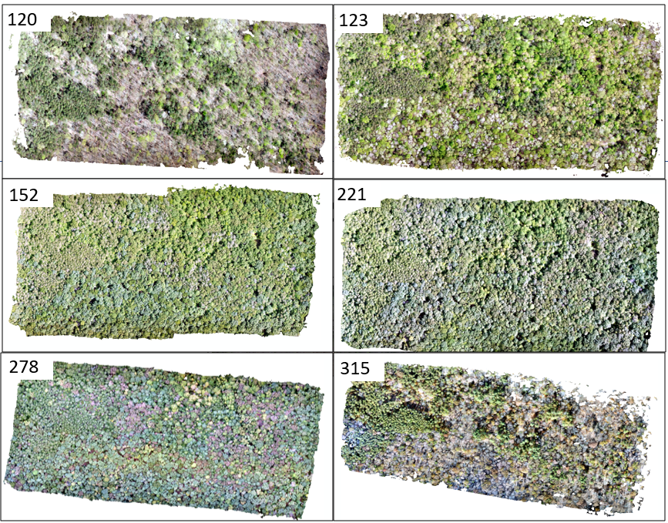

Figure 4: Examples of the orthomosaics with dates ranging from day of year 120 (4/24/2018) to day of year 315 (11/11/2018).

The green chromatic coordinate (GCC) is calculated for the orthomosaic layer using

|  |  |  |
| --- | --- | --- |
|  | $$GCC=\frac{G}{R+G+B}$$ | (1) |

where G is number of green pixels, R is the number of red pixels, and B is the number of blue pixels. The GCC equation gives a relative greenness value that is between 0 and 1 for each cell. The GCC vegetation index was found to outperform other indices such as NDVI for near ground images. Additionally, since GCC measures the proportions of different wavelengths of light, it is able to standardize differences in scene illumination (Reid et al. 2016). After the GCC was calculated, the zonal statistics tool in ArcMap was used to give an array of statistics for each crown such as the mean GCC, the range of GCC values within the crown, and the area of the crown.

*Analysis*

The mean GCC data were imported into Microsoft Office Excel where the data was organized by date and crown ID. MATLAB R2017a was used to calculate day of year, abbreviated as DOY, and fit a curve to GCC over time.  The equation

|  |  |  |
| --- | --- | --- |
|  | GCC(t) = $a+(b-c*t)(\frac{1}{1+e^{\frac{d-t}{e}}}-\frac{1}{1+e^{\frac{f-t}{g}}}$) | (2) |

was used to combine the spring increasing curve and fall decreasing curve while also accounting for declining summer greenness, where t is time and a-g are parameters described in table 1 (Elmore et al., 2012).

|  |  |  |
| --- | --- | --- |
| **Parameter** | **Description** | **Value** |
| a | Minimum vegetation cover | 0.3 |
| b | Potential amplitude | 0.1 |
| c | Summer greendown | 0.0002 |
| d | Spring onset of greenness | 120 |
| e | Slope of spring onset | 8 |
| f | Autumn offset of greenness | 305 |
| g | Slope of autumn offset | 7 |

Table 1: Parameters used in equation 1 to create phenology curve.

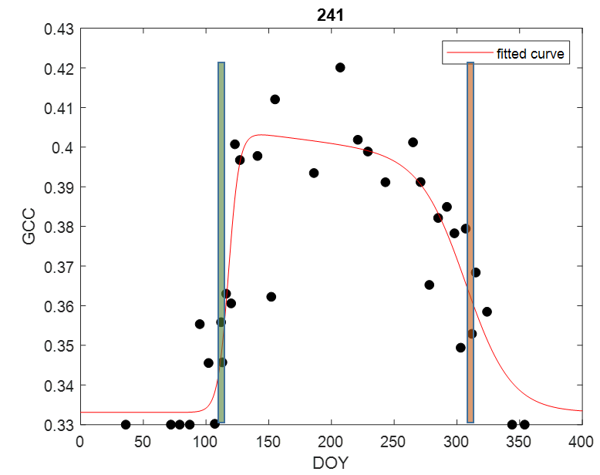Figure 5: Phenology curve for tree 241 where the green bar represents the budburst and the orange bar represents fall senescence.

In order to increase the accuracy of the curve fitting, four additional dates were added to the beginning of the data set and two were added at the end.  GCC values of 0.33 were assumed for all of these dates based on previous knowledge of wintertime GCCconditions. Start of season and end of season were calculated using equation 1 for all deciduous trees, as shown in figure 5.  Evergreen trees were flagged and excluded from calculations. Using eqn. 1, start of season is defined as the halfway point in the increasing spring phenology curve and end of season is the halfway point in the decreasing fall phenology curve. Phenology curves were output for each tree crown and tree crowns were removed from consideration if the curve was too sharp and did not represent a smooth transition in canopy color. For example, figures 5B and 5C are examples of curves that fairly represents the data and show smooth transitions, giving an accurate start of season, whereas figure 5A is a curve that is too sharp and does not give an accurate start of season.

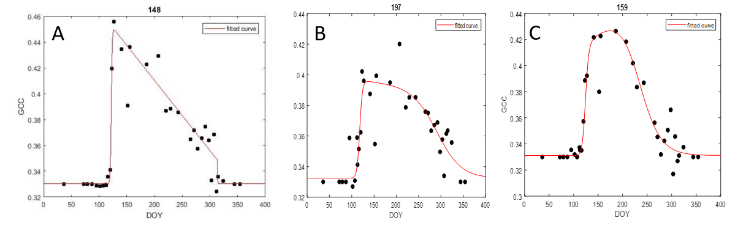

Figure 6: Examples of Gcc data over time with a fitted curve (eqn. 2).

After the data was cleaned and start of season was calculated, ESRI ArcMap 10.6 was used to examine spatial variability. Start of season data was joined to tree crown data and 32 natural breaks were used to separate start of season dates. Five points were added to the spatial variability map in areas with start of season similarities and 50 meter buffers were added to each point. The buffers were in distinct areas of the study site with sufficient numbers of tree crowns and were adjusted so the buffers did not overlap. All tree crowns within or partially within each 50 meters radius were selected and output into new data sets.

The statistical software R 3.5.2 was used for analysis of collected variables. The available data for this study were GCC values, height values, start of season and end of season dates, and tree crown area. The package ggplot2 was used to examine the relationships between several of these variables and calculate basic statistical properties.

**Results**

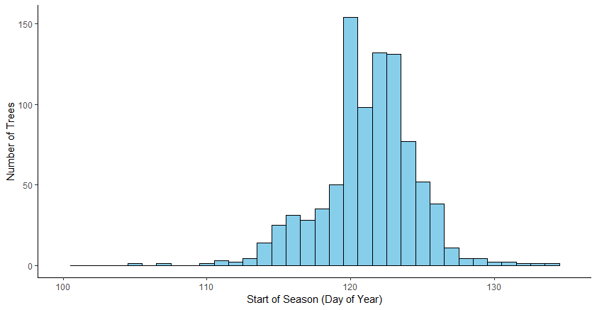Figure 7: Histogram showing the number of trees for the start of season dates.

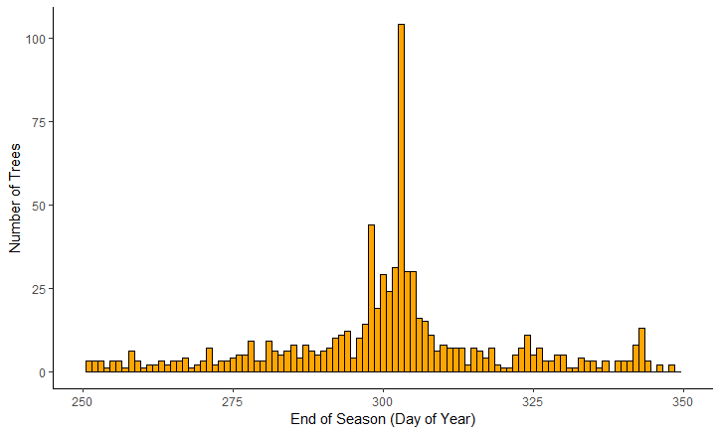

Figure 8: Histogram showing number of trees for the end of season dates.

After all evergreen trees and trees with phenology curves that were thought to be incorrect were removed, there was a total of 914 trees that we believed to have accurate start of season dates, as shown in figure 7. Although end of season was also calculated for each tree crown as well (Figure 8), we believe that these dates are less accurate and did not consider them in our analysis. The median start of season day of year is 122 (5/22), the range is 30, and the 1st and 3rd quartiles are 119.9 and 132.2, respectively. Figure 8 shows that many trees begin their season in one distinct period. Days of year 120-124 are when the majority of the trees being observed start their season. However, the start of season for the entire study site ranges from 105 (4/15) to 135 (5/15).

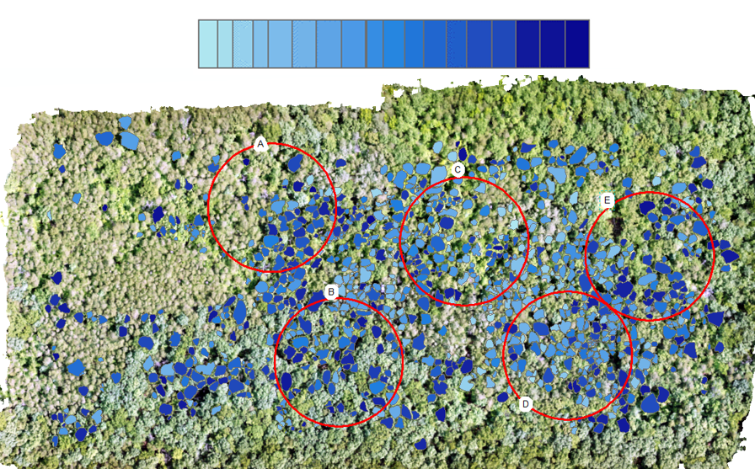

Figure 9: A spatial variability map where lighter shades of blue correspond to earlier start of season and darker shades of blue correspond to later start of season. The 5 buffer areas are labeled A-E.

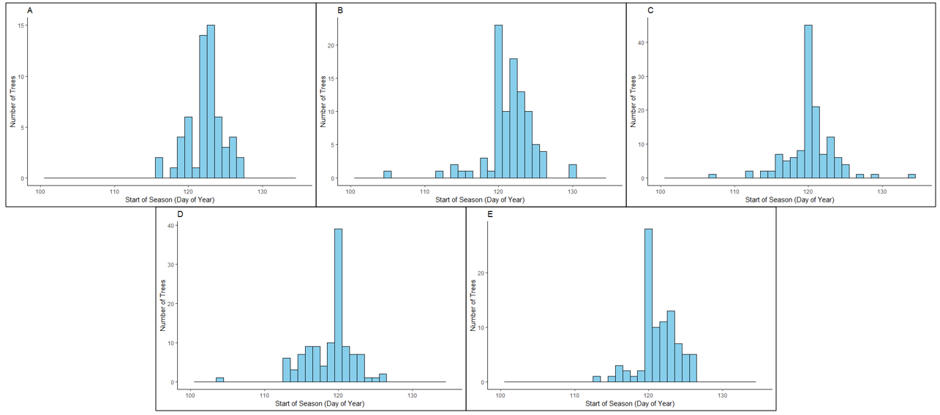

Figure 10: Histograms showing start of season labeled A-E that correspond to the buffers in Figure 9.

Start of season was also examined spatially, as seen in Figures 9 and 10. Figure 9 shows the color gradient of start of season dates, where start of season is later as the shades of blue become darker. There are areas in the study site where the start of season patterns are similar, however these patterns are subtle considering the shades of blue are well mixed. The spatial variability in start of season is also examined quantitatively with the placement of buffers (Figure 9). The five buffers are labeled A-E and histograms were created for the trees located within each buffer. Statistics calculated for each buffer are rounded to the nearest whole day of year. Buffer A has a total of 58 trees with a median start of season date of 123, a 1st quartile of 122, and a 3rd quartile of 124. Buffer B has a total of 97 trees with a median start of season date of 122, a 1st quartile of 120, and a 3rd quartile of 123. Buffer C has a total of 120 trees with a median start of season date of 120, a 1st quartile of 119, and a 3rd quartile of 121. Buffer D has a total of 116 trees with a median start of season date of 120, a 1st quartile of 117, and a 3rd quartile of 120. Buffer E has a total of 89 trees with a median start of season date of 121, a 1st quartile of 120, and a 3rd quartile of 123.

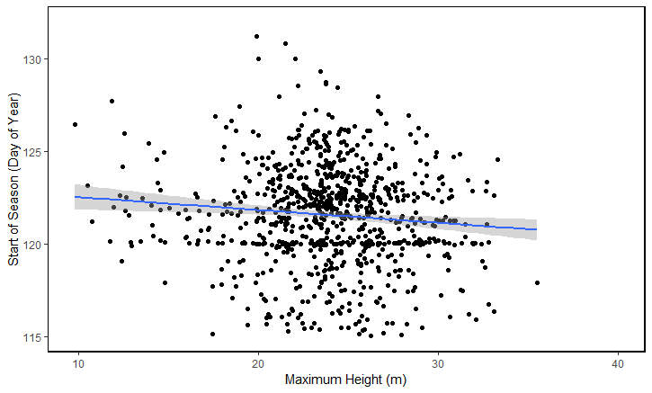

Figure 11: Maximum tree height in meters and start of season in day of year.

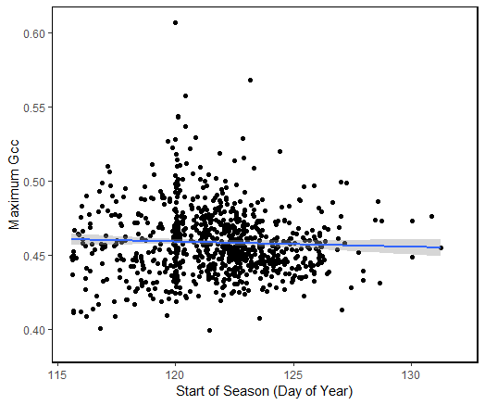

Figure 12: Start of season in day of year and maximum GCC.

Tree height, both maximum and average, was plotted against start of season. The maximum and average tree heights were similar and their relationship to start of season was also similar, so only maximum tree height is included (Figure 11). The adjusted R2 for this relationship is 0.008 and the P value is .004, suggesting that there is no significant correlation between tree height and start of season in this case. Start of season was also plotted against maximum GCC (Figure 12) and an adjusted R2 value of 0.006 was found and a P value of 0.008 was found. Again, this suggests that there is not a significant correlation between start of season and maximum GCC.

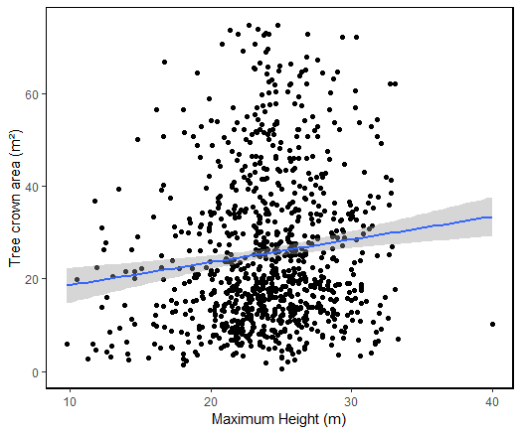

Figure 13: Maximum tree height in meters and tree crown area in square meters.

Tree crown area, estimated from the area of the polygons assigned to the tree crowns, was calculated in ArcMap using the geometry tool. Figure 13 shows tree crown area plotted against maximum tree height. The adjusted R2 and P value for this relationship are 0.001 and 0.01, respectively, suggesting that there is so significant correlation.

**Discussion**

*Drone Methodology*

The first goal of this study, to understand the effectiveness of using drones to observe tree phenology, is particularly important since this method has become readily available only within the last 10 years. The price of a drone and the associated equipment can be more competitive than purchasing remotely sensed data from groups such as PlanetLab. Using a drone can have advantages besides cost and high resolution. Schedules can be easily customized to fit the exact need of the study. In this study, a flight schedule was created so that phenology was able to be observed at a high temporal frequency during the spring and fall, and a lower frequency during the summer when phenology is constant. Furthermore, flight plans can be customized for the need of the study. Here, we created a flight plan that included a mixed forest in an area that had height data and a flux tower for easy referencing. Creating a custom flight plan allows for the inclusion or exclusion of a given area, which removes unnecessary data and helps with future processing.

There were several difficulties in using a drone to collect data as well as with the subsequent processing software. The orthomosaics for the early dates had holes in them where Agisoft Photoscan was not able to find enough points in common to complete the area. This problem was mostly alleviated when using infinite tie points and high accuracy. Here, high accuracy was decided upon because using highest accuracy greatly increased the processing time in Agisoft Photoscan. Another issue with using drones as a method of data collection is the meteorological conditions. While fog and clouds affects both drones and satellite sensed images, drones are also influenced by the wind. In this study, the light-weight drone (Figure 1) was unable to fly when wind speeds were over 8 m/s. This narrowed the range of days where data collection was possible. On days when the drone was flown and wind was under 8 m/s, the drone was often forced off of its flight path by several meters and caused trees to be viewed at slightly different angles depending on the day. However, this issue was corrected by the method of manually shifting the polygons onto the tree crowns as described in the methods section. A benefit of having data on a large number of trees was that the exclusion of bad or unexplainable data did not negatively affect the statistical significance of the overall data set.

*Relationships*

The second goal of this study was to assess potential relationships between several variables derived from LIDAR data and drone images. The variables included in this analysis were maximum tree height versus start of season, maximum GCC versus start of season, and maximum tree height versus tree crown area. On their own, these first two relationships might suggest that there was error in calculating GCC or start of season, and while we can’t completely ignore that, the third relationship suggests that something else may be responsible for these results. Tree height and crown area are physical variables that have high accuracy in this study, suggesting that there is another factor influencing this weak relationship. A study by Seiwa found that tree height and tree crown area are strongly correlated on the species level, so the lack of species data may have at least played a part in creating weak relationship between the variables examined in this study (1998).

The histograms of the individual tree crowns show start of season densities in different areas. The fact that these histograms exhibit different patterns from the histogram of the entire study site (Figure 7) suggests that start of season is species dependent and also points towards the possibility of microclimates influencing start of season. An early study found that plots on slightly different terrain, but in the same area experienced flowering up to 6 days earlier than other plots with the same species (Jackson, 1996). The median start of season dates for the different buffers in this study only vary by two days, but it is possible that small variations in microclimate could be responsible for these differences. Understanding the impacts of microclimates on tree phenology is important because it can help explain variations in start of season and end of season timing. Therefore, generalizing the phenology of an area could create inaccuracies when attempting to calculate carbon uptake or risk of frost damage.

*Future Work*

In future studies, identifying the different tree species in the study site could be improve the correlations examined here. One option for doing this would be to identify the species of every tree for which data was collected. However, this could be very labor intensive and not feasible for large areas. Another option could be to develop an equation, similar to the one in Elmore et al., but include more parameters that could take into account a range of tree species. In this way, species of tree would not have to be identified for every individual, instead the tree species included in the area would have to be identified.

More work could be done to examine different types of drones. For example, a larger drone may be able to fly in windier conditions and for a longer period of time. Drones with sensors that include near-infrared or other wavelengths could be used as well. Using drones to examine other types of forests could also be beneficial because it would give others information on how well drone based images can observe phenology in their study area.

**References**

Anderson, Karen, and Kevin J. Gaston. “Lightweight Unmanned Aerial Vehicles Will Revolutionize Spatial Ecology” *Frontiers in Ecology and the Environment*, vol. 11, no. 3, Apr. 2013, pp. 138-146

Berra, Elias F., et al. “Use of a Digital Camera Onboard a UAV to Monitor Spring Phenology at Individual Tree Level.” *2016 IEEE International Geoscience and Remote Sensing Symposium (IGARSS)*, 2016, doi:10.1109/igarss.2016.7729904.

Elmore, Andrew J., et al. “Landscape Controls on the Timing of Spring, Autumn, and Growing Season Length in Mid-Atlantic Forests.” *Global Change Biology*, vol. 18, no. 2, 2011, pp. 656–674., doi:10.1111/j.1365-2486.2011.02521.x.

Jackson, Marion T. “Effects of Microclimate on Spring Flowering Phenology.” *Ecology*, vol. 47, no. 3, 1966, pp. 407–415., doi:10.2307/1932980.

Keenan, Trevor F., et al. “Net Carbon Uptake Has Increased through Warming-Induced Changes in Temperate Forest Phenology.” *Nature Climate Change*, vol. 4, no. 7, Jan. 2014, pp. 598–604., doi:10.1038/nclimate2253.

Keenan, T. F., B. Darby, E. Felts, O. Sonnentag, M. A. Friedl, K. Hufkens, J. O'Keefe, S. Klosterman, J. W. Munger, M. Toomey and A. D. Richardson. “Tracking forest phenology and seasonal physiology using digital repeat photography: a critical assessment.” *Ecological Applications*, vol. 24, no. 6, September 2014, pp. 1478-1489.

Klosterman, Stephen, and Andrew Richardson. “Observing Spring and Fall Phenology in a Deciduous Forest with Aerial Drone Imagery.” *Sensors*, vol. 17, no. 12, 2017, p. 2852., doi:10.3390/s17122852.

Klosterman, Stephen, Eli Melaas, Jonathan A. Wang, Arturo Martinez, Sidni Frederick, John O’Keefe, David A. Orwig, Zhuosen Wang, Qingsong Sun, Crystal Schaaf, Mark Friedl, Andrew D. Richardson. “Fine-scale perspectives on landscape phenology from unmanned aerial vehicle (UAV) photography.” *Agriculture and Forest Meteorology*, vol. 248, January 2018, pp. 397-407.

Lisein, Jonathan, et al. “Discrimination of Deciduous Tree Species from Time Series of Unmanned Aerial System Imagery.” *Plos One*, vol. 10, no. 11, 2015, doi:10.1371/journal.pone.0141006.

Parihar, J. S., Sheshakumar Goroshi, R. P. Singh, N. S. R. Krishnayya, M. B. Sirsayya, Alok Kumar, L. S. Rawat, and Ajit Sonakia. “Observation of Forest Phenology Using Field-based Digital Photography and Satellite Data.” *Current Science*, vol. 105, no. 12, December 2013, pp. 1740-1746.

Parmesan, Camille. “Ecological and Evolutionary Responses to Recent Climate Change.” *Annual Review of Ecology, Evolution, and Systematics*, vol. 37 pp. 637-690.

Polgar, Caroline A., and Richard B. Primack. “Leaf-out Phenology of Temperate Woody Plants: from Trees to Ecosystems.” *New Phytologist*, vol. 191, no. 4, 2011, pp. 926–941., doi:10.1111/j.1469-8137.2011.03803.x.

Reid, Anya M., et al. “Using Excess Greenness and Green Chromatic Coordinate Colour Indices from Aerial Images to Assess Lodgepole Pine Vigour, Mortality and Disease Occurrence.” *Forest Ecology and Management*, vol. 374, 2016, pp. 146–153., doi:10.1016/j.foreco.2016.05.006.

Seiwa, K. “Changes in Leaf Phenology Are Dependent on Tree Height InAcer Mono, a Deciduous Broad-Leaved Tree.” *Annals of Botany*, vol. 83, no. 4, 1999, pp. 355–361., doi:10.1006/anbo.1998.0831.

Way, D. A. “Tree Phenology Responses to Warming: Spring Forward, Fall Back?” Tre Physiology, vol. 31, no. 5, Jan. 2011, pp. 469–471., doi:10.1093/treephys/tpr044.

Xu, Hong, Tracy E. Twine, Xi Yang. “Evaluating Remotely Sensed Phenological Metrics in a Dynamic Ecosystem Model.” *Remote Sensing*, vol. 6, no. 6, May 2014, pp. 4660-4686.

Yang, Xi. Jianwu Tang, John F. Mustard. “Beyond leaf color: Comparing camera‐based phenological metrics with leaf biochemical biophysical and spectral properties throughout the growing season of a temperate deciduous forest.” *J. Geophys. Res. Biogeosci.*, 119, 181–191, doi: 10.1002/2013JG002460.

Zhang, Jian, et al. “Seeing the Forest from Drones: Testing the Potential of Lightweight Drones as a Tool for Long-Term Forest Monitoring.” *Biological Conservation*, vol. 198, 2016, pp. 60–69., doi:10.1016/j.biocon.2016.03.027.